CAN OBJECTIVE QUESTIONS SET 6
- Any CAN node switches from Bus-Off state to Active-Error state if______________.
a) it is RESET b) 128 occurrences of 11 consecutive “recessive” bits on bus
c) a or b options d) a & b options
- If a CAN node is alone on the bus and tries to transmit then ____ is/are true.
a) The node will win the arbitration and proceed with the message transmission.
b) During the ACK slot,no node will send a dominant bit so the transmitter will sense an ACK error.
c) a & b options
d) no options
- Which among the following is a CAN transceiver ______________.
a) AT89S52 b) MCP2551 c) P89V51RD2 d) MCP2515
- MCP2515 CAN controller implements ______ at 1Mb/s .
a) CAN2.0A b) CAN2.0B c) CAN FD d) all of the mentioned
- MCP2515 CAN controller support SPI modes ______________ at ______ MHz max.
a) 0,3,10 b) 1,2,10 c) 0,3,5 d) 1,2,5
- The Bit Timing Configuration registers in MCP2515 CAN controller are _______.
a) CNF1 b) CNF2 c) a & b d) c & more
- When using MCP2515 CAN controller(TQ= 2 . BRP. TOSC),assuming that 125kHz CAN baud rate with Fosc=20MHz is desired. TOSC = 50 ns, choose BRP =5, then TQ = 500 ns. To obtain 125 kHz, the bit time must be ____ TQ.
a) 5 b) 10 c) 16 d) 18
- The MCP2515 has _____modes of operation. And in ________ mode ONLY which transmit / receive frames.
a) 5,Configuration b) 5,Normal c) 5,Loop back d) 3,Normal

- When using MCP2515 CAN controller's SPI Interface _______ instruction,provides a means for setting or clearing individual bits in specific status and control registers.
a) Bit Modify b) Reset c) Read d) Write
- When using MCP2515 CAN controller's SPI Interface _______ waveform is used for setting or clearing individual bits in specific status and control registers.
a)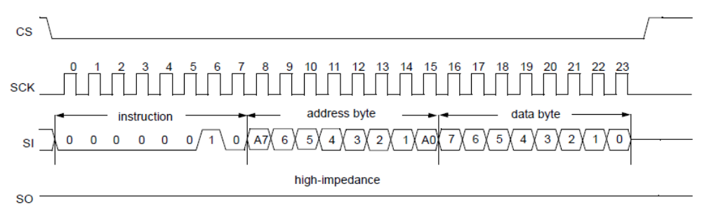
b)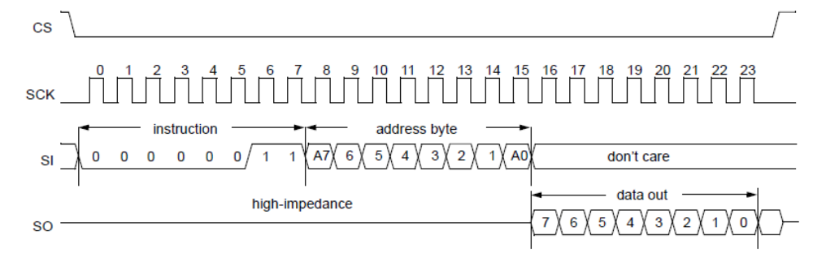
c)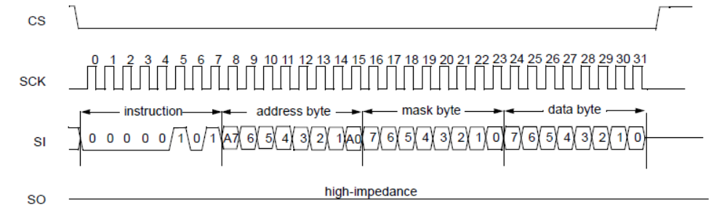
d) None of the above.
- When using MCP2515 CAN controller's SPI Interface _______ waveform given in options of question 69 is used for “Byte Write Instruction”.

- Given below are two CAN nodes. Identify & Complete the connectivity between CAN controller & CAN Transceiver of each node and also between the two CAN nodes ,by drawing directed lines.
